Task 1
Create a GitHub repository and clone it to your machine.
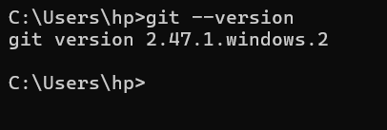
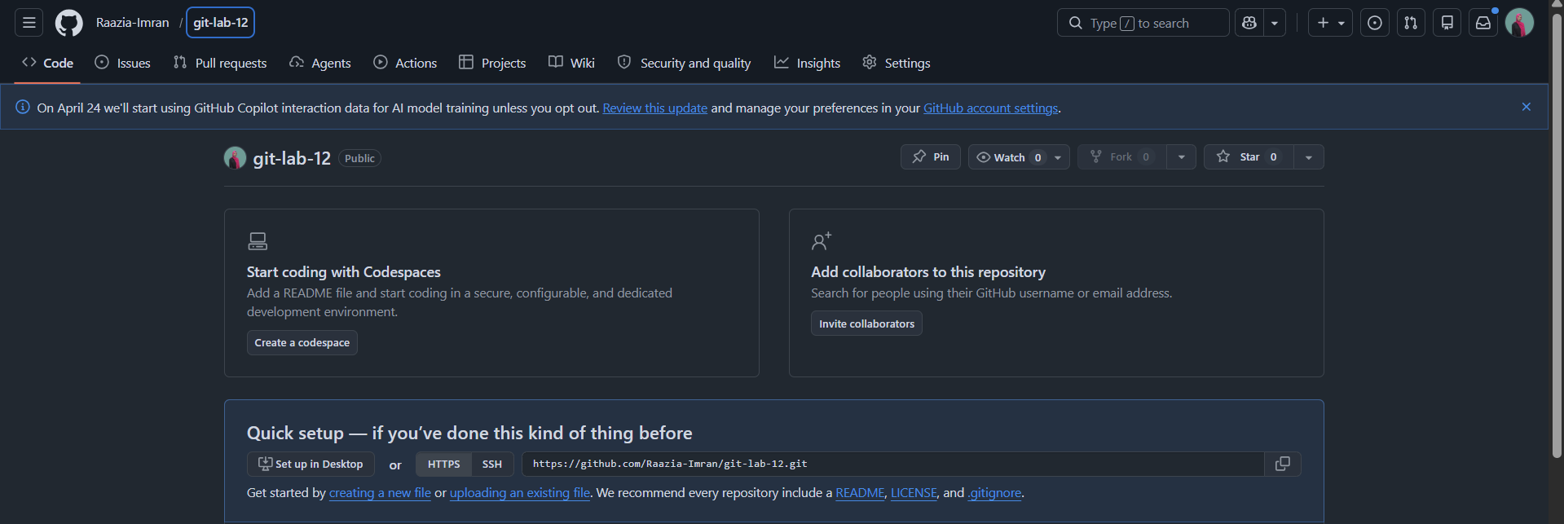
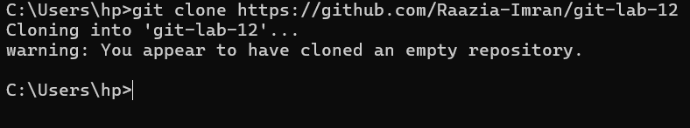
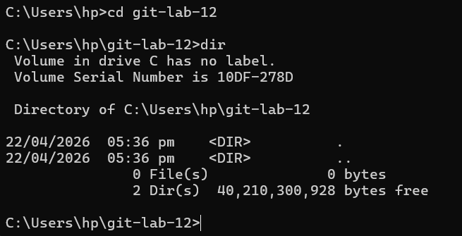

Task 2
Add a new file, stage it, commit it, and push it to GitHub.
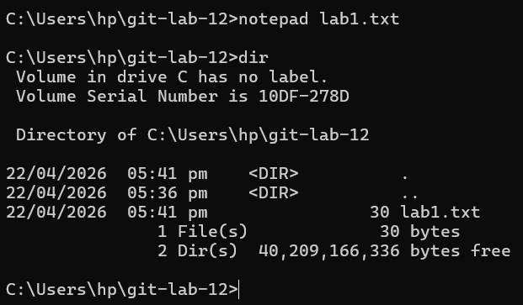
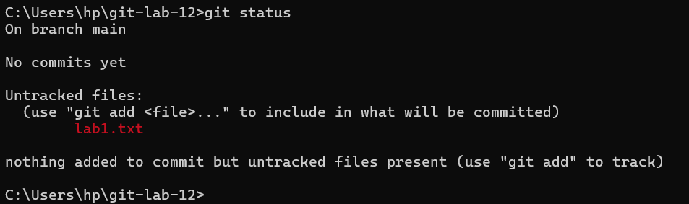
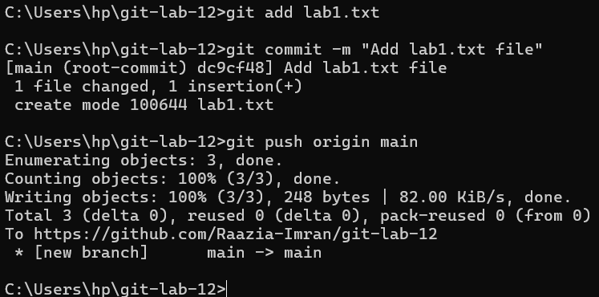

Task 3
Modify the file and push the update. Observe changes on GitHub.
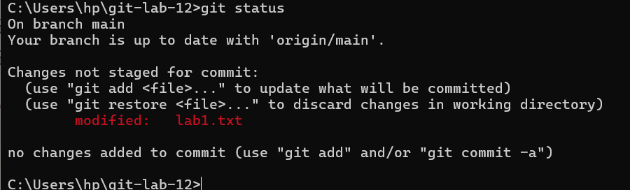
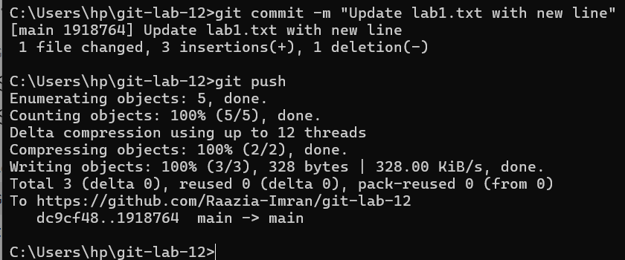
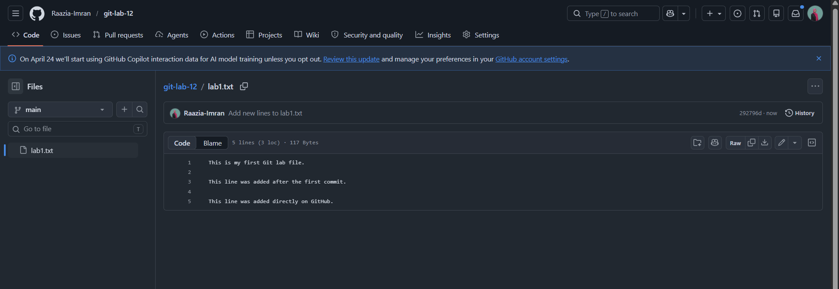

Task 4
Pull updates from remote if changes are made online.
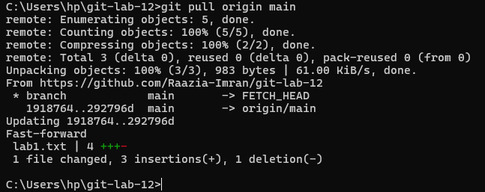

Task 5
Optional: Create a new branch, make changes, push it, and open a pull request.
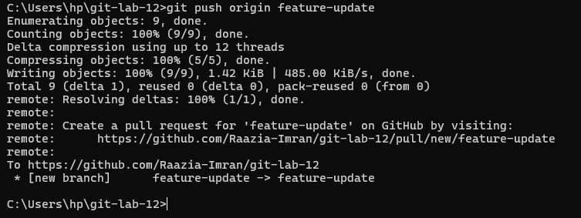
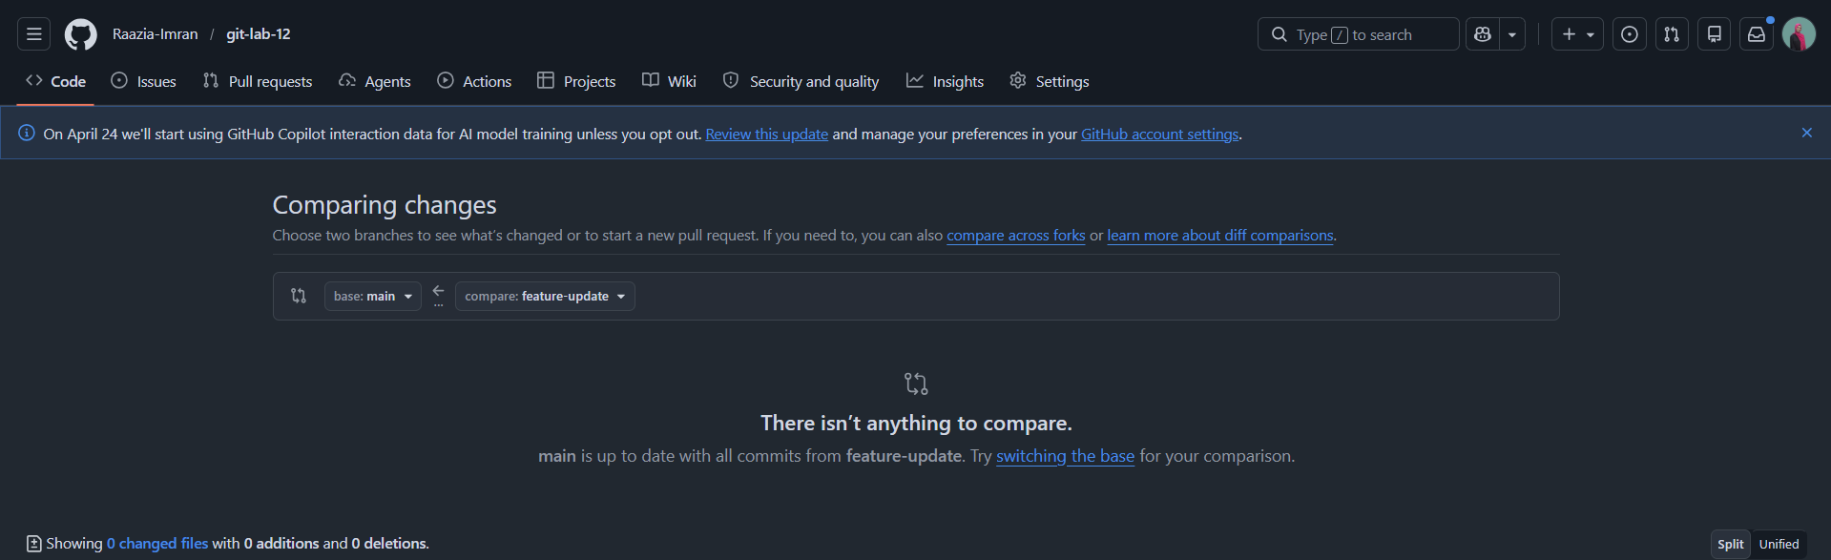

Task 6
Explain the purpose of each Git command used in the lab.
Command | Purpose
git clone | Copies a remote repository to the local machine
git status | Shows the current state of files
git add | Stages files for commit
git commit | Saves staged changes with a message
git push | Uploads commits to GitHub
git pull | Fetches and merges changes from remote
git checkout -b | Creates and switches to a new branch

